MATH 3 COURSE SYLLABUS
Instructor: Mr. Schotten
Room: 102
Phone: (517) 303-4574
Email: c1.schotten@cms.k12.nc.us
Website: http://schotten.weebly.com
Tutorials: Monday 2:30-4:00pm

REMIND
Text @MTH3-1 to 81010
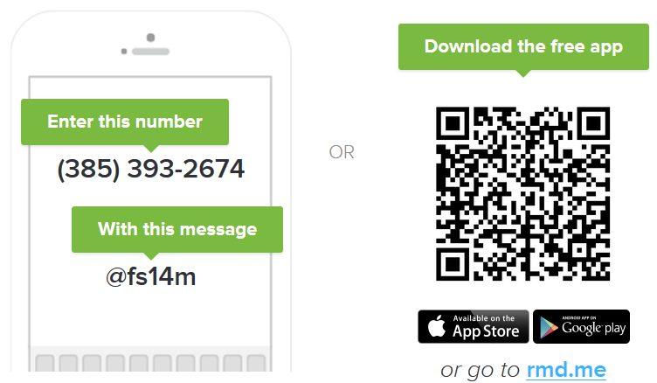
Course Objectives:
By the end of the course, students will be able to:
- Simplify and multiply radicals
- Interpret the structure of expressions
- Perform arithmetic operations with polynomial expressions
- Understand the relationship between zeros and factors of quadratics
- Perform algebraic and geometric transformations
Course Requirements:
Prerequisites: Successful completion of Math 1 and Math 2 (formerly Algebra I and Geometry)
Required Materials: (Each student is responsible for bringing the following items to class every day.)
- Composition notebook, graph ruled (100+ pages)
- 2 pocket folder
- Loose-leaf paper, college-ruled paper
- Loose-leaf graph paper
- PENCILS, PENCILS, PENCILS!!!
- TI-83 Graphing Calculator (will be provided in class ONLY; however, students are encouraged to purchase one for home use) *Online graphing calculator available: http://www.desmos.com, Android: Graphing Calculator by Mathlab, iPhone: Graphing Calculator by Desmos.
Personal Conduct:
- You are free to pursue your academic success in any way that also promotes success for your peers.

Sample Interventions for Misconduct:
- Verbal Warning
  - You will be given one verbal warning and redirection to change your conduct.
- Student-Teacher Conference
  - We will have a conference during or after class to discuss your conduct and positive actions to take in order to correct this behavior and refocus on your learning.
- Forfeiture of Privilege (e.g. confiscation of electronic device)
- Seat Change
- Behavioral Reflection Writing Assignment
- Parent/Guardian Conference/Contact
  - I will contact an important adult figure in your life to consult with regarding your behavior. This person can be your parent, coach, sibling, aunt, uncle, grandparent, or any other significant adult figure.
- Referral or Removal from Classroom
- For less severe behaviors, you will be removed from my classroom for the remainder of the period. You will be sent to sit quietly in another teacher’s classroom. If you are sent to another room, you may not re-enter my classroom until after the final bell for the day has rung.
- For repeated infractions of the same nature or more severe misconduct (i.e. “major,” as deemed by WMHS), you may be removed from my classroom, and receive a referral to your AP. You will not be allowed to re-enter my classroom until the following day.

Academic Grading Policy: Grading Scale:
- Final = 25% 93-100 A
PER QUARTER: 85-92 B
- Tests, Quizzes, Projects, ISN = 70% 77-84 C
- Homework, Classwork, Warm Ups, Exit Tickets, Participation = 30% 70-76 D
69 and under F
* Grading will be done in a manner so that it is interpreted as a measure of learning and will not include controllable nonacademic factors as extra points for signatures, loss of points for writing in ink, etc. My purpose for grading is to communicate how much learning has been accomplished.

Attendance and Tardy Policy:
- Each student is expected to be in class every day on time. “ON TIME” means in your seat, ready to start when the bell rings. It does NOT mean running into the room as the bell is ringing.
- Excessive absences (more than 10 unexcused absences) will result in a failure of the class per district policy. *Attendance and tardy policies are listed and further explained in the parent-student handbook.

Homework and Make-Up Work Policy:
- Homework will be assigned regularly to reinforce class objectives and student mastery.
- It is the student’s responsibility to gather all make-up work and complete it in a timely manner (per district policy, within 5 school days of his/her return to school, unless prior arrangements have been made). Generally, tests that need to be made up will not be done during class time. You must arrange to make up tests after 2:30pm.

Teacher Availability:
- After school tutoring will be provided on Mondays from 2:30-4:00pm.
  - An appointment will need to be arranged with Mr. Schotten otherwise.
* It is the student’s responsibility to let me know if he/she needs to come for extra help. It is very important that a student does not fall behind, because it is often very difficult to catch up. Please ask for help before you get behind.

Communication with Parents:
Parent contact is made regularly, via phone calls, progress reports, email, and parent conferences as needed. A log is kept of all parental contact. I respond promptly (within 48 hours) to all messages from parents. Parents may contact me through my website (http://wmhsmath2santos.weebly.com) or directly via email address listed at the beginning of this document. I will also send a text via Remind.com to students and parents enrolled in the program the night before every unit test and big project.
Course Calendar
*Because our primary goal is to maximize student achievement, material may be added, deleted, and/or substituted at the teacher’s discretion based on the individual needs, levels, and learning styles of each class. Creative projects, written assignments, and supplemental materials may be included also throughout the year as opportunities arise. Please keep in mind that the dates listed are fluid and are subject to change due to school activities, inclement weather, or customizing the pace of the units to the students’ needs. This is intended as a guide only.
Units
Unit 1: Polynomials | Unit 5: Geometry
Unit 2: Radicals & Complex Numbers | Unit 6: Trigonometry
Unit 3: Logarithmic & Exponential Functions | Unit 7: Modeling
Midterms | Final Exams
Unit 4: Probability & Statistics

